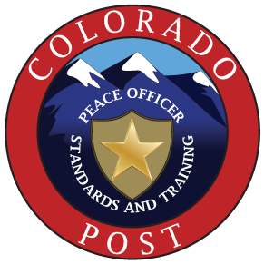**SME Curriculum Committee**

**Meeting Minutes**

**Thursday, November 2, 2023 at 0900**

**Remote Zoom Meeting**

**Members in Attendance:**

Agent Megan Alstatt, CBI

Director Stu Curry, Colorado Mountain College

Sgt. James Gerhardt, Thornton PD

Investigator JoeRyan Hartley, 18th Judicial District

Asst. Director Dan Hotsenpiller, Technical College of the Rockies LEA

Act. Commander, Timothy Jungclaus, Adams County SO

Ms. Janet Larson, citizen, Chair

Corporal Vincent Maffett, CSU PD

Technician Stephen Marino, Denver PD

Dr. Kathleen Mitchell, citizen

Dave Swavely, citizen

Training Coordinator Janice Worthem, Colorado State Patrol

**Excused:**

Deputy Keenan Dukes, El Paso County SO

Lt. Marc Weber, Larimer County SO

**Unexcused:**

Director Vincent Fraker, Otero JC

**Resignations:**

Sgt. Gina Seago, Colorado Springs PD

**POST Representative:**

Courtnay Schwartz, POST

Rollcall to establish that a quorum is present.

Review / Approval of October 5, 2023, meeting minutes.

Introduce guests present: None

Courtnay Schwartz – POST:

Renewal Update:

The committee is still working on renewal lesson plans. Arapahoe Community College has one approved. Denver PD does not have any approved. Jeffco/Lakewood have submitted three revisions, two of which are not approved.

Thornton PD Basic Academy Update:

They have uploaded 93% of their courses. We have reviewed 32 of those with 7 approved and 25 not approved. There are 19 courses to be reviewed. The subcommittees are to review them and adhere to the stipulated deadlines.

**NEW BUSINESS:**

A Vice Chair is required by rule. Submit nominations to Janet and the committee will vote on the position at the next meeting.

Review injury reports from TCR and Highlands Ranch academies

**OLD BUSINESS:**

The committee approved the Academy site for the CSPD Academy.

The committee approved the Academy site for the Colorado Rangers.

Curriculum Revisions: All of the sections discussed at previous meetings were unanimously approved by the committee. Janet will submit a redline document (dated 11/2/23) to POST for approval at the December board meeting.

As requested by POST, the committee discussed reducing the number of hours of interaction with special populations from 8 to 4 for the reserve academy. There were no objections.

Motion / Approval to adjourn meeting at 1110 hours.

**The next committee meetings will be November 30, 2023, January 4, and February 1, 2024. All will be at 0900 and will be remote. The next POST Board meeting will be December 1 at 1000 in Denver.**